EXPERIMENT 03: CLI,GUI AND VUI

AIM: The aim is to develop and compare Command Line Interface (CLI), Graphical User

Interface (GUI), and Voice User Interface (VUI) for the same task, and assess user

satisfaction using Python (with Tkinter for GUI and Speech Recognition for VUI) and

Terminal.

PROCEDURE:

1. Implement a **CLI To-Do List** in Python for adding, viewing, and removing tasks via terminal input.
2. Develop a **GUI To-Do List** using Tkinter with text input, buttons, and a task list display.
3. Build a **VUI To-Do List** using SpeechRecognition and pyttsx3 for voice commands.
4. Compare user experience across CLI, GUI, and VUI interfaces.

PROGRAM:

CLI- Command line interface

tasks=[]

def add_task(task):

    tasks.append(task)

    print(f"Task '{task}'added.")

def view_tasks():

    if tasks:

        print("Your tasks:")

        for idx,task in enumerate(tasks,1):

            print(f"{idx}.{task}")

    else:

        print("No tasks to show.")

def remove_task(task_number):

    if 0< task_number <= len(tasks):

        removed_task=tasks.pop(task_number-1)

        print(f"Task'{removed_task}'removed.")

    else:

        print("Invalid task number.")

def main():

    while True:

        print("\nOptions: 1. Add Task 2.View Tasks 3.Remove Task 4.Exit")

        choice=input("enter yoour choice:")

        if choice=='1.':

            task=input("Enter task: ")

            add_task(task)

        elif choice=='2.':

            view_tasks()

        elif choice == '3.':

            task_number=int(input("Enter task number to remove: "))

            remove_task(task_number)

        elif choice =='4.' :

            print("Exiting..")

            break

        else:

            print("Invalid choice. Please try again.")

if __name__=="__main__":

                  main()

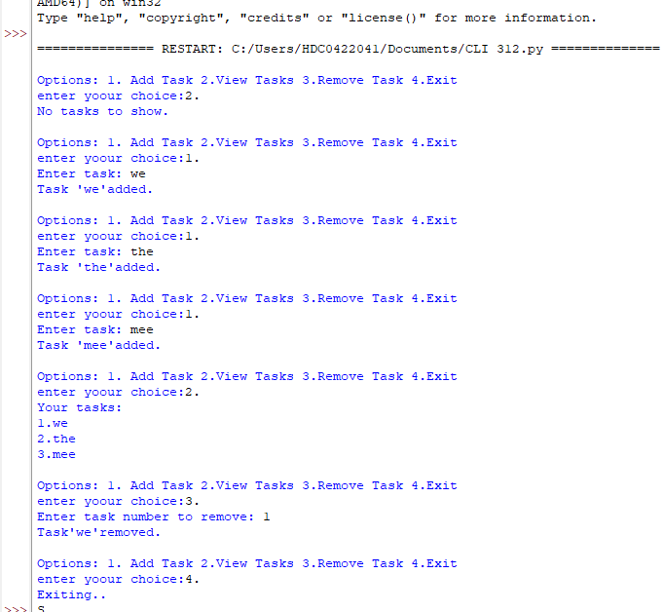

GUI – Graphical User Interface

import tkinter as tk

from tkinter import messagebox

tasks = []

def add_task():

    task = task_entry.get()

    if task:

        tasks.append(task)

        task_entry.delete(0, tk.END)

        update_task_list()

    else:

        messagebox.showwarning("Warning","Task cannot be empty.")

def update_task_list():

    task_list.delete(0, tk.END)

    for task in tasks:

        task_list.insert(tk.END, task)

def remove_task():

    selected_task_index = task_list.curselection()

    if selected_task_index:

        task_list.delete(selected_task_index)

        tasks.pop(selected_task_index[0])

app = tk.Tk()

app.title("To-Do List")

task_entry = tk.Entry(app, width=40)

task_entry.pack(pady=10)

add_button = tk.Button(app, text="ADD Task",command=add_task)

add_button.pack(pady=5)

remove_button = tk.Button(app, text="Remove Task", command=remove_task)

remove_button.pack(pady=5)

task_list = tk.Listbox(app, width=40, height=10)

task_list.pack(pady=10)

app.mainloop()

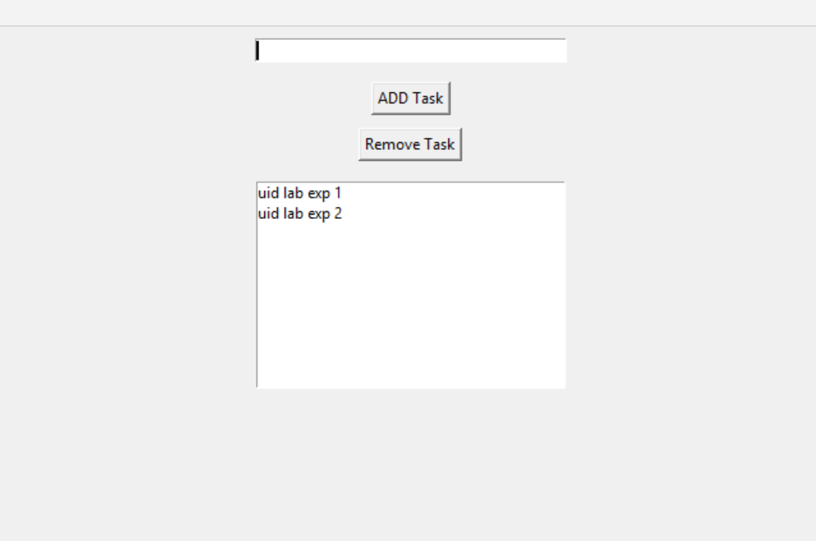

VUI – Voice User Interface

import speech_recognition as sr

import pyttsx3

tasks = []

recognizer = sr.Recognizer()

engine = pyttsx3.init()

def add_task(task):

    tasks.append(task)

    engine.say(f"Task {task} added")

    engine.runAndWait()

def view_tasks():

    if tasks:

        engine.say("Your tasks are")

        for task in tasks:

            engine.say(task)

    else:

        engine.say("No tasks to show")

    engine.runAndWait()

def remove_task(task_number):

    if 0 < task_number <= len(tasks):

        removed_task = tasks.pop(task_number - 1)

        engine.say(f"Task {removed_task} removed")

    else:

        engine.say("Invalid task number")

    engine.runAndWait()

def recognize_speech():

    with sr.Microphone() as source:

        print("Listening...")

        audio = recognizer.listen(source)

        try:

            command = recognizer.recognize_google(audio)

            return command

        except sr.UnknownValueError:

            engine.say(";Sorry, I did not understand that")

            engine.runAndWait()

            return None

def main():

    while True:

        engine.say("Options: add task, view tasks, remove task, or exit")

        engine.runAndWait()

        command = recognize_speech()

        if not command:

            continue

        if "add task" in command:

            engine.say("What is the task?")

            engine.runAndWait()

            task = recognize_speech()

            if task:

                add_task(task)

        elif "view tasks"in command:

            view_tasks()

        elif "remove task" in command:

            engine.say(";Which task number to remove?")

            engine.runAndWait()

            task_number = recognize_speech()

            if task_number:

                remove_task(int(task_number))

        elif "exit" in command:

            engine.say(";Exiting...")

            engine.runAndWait()

            break

        else:

            engine.say(";Invalid option. Please try again.")

            engine.runAndWait()

if __name__ == "__main__":

    main()

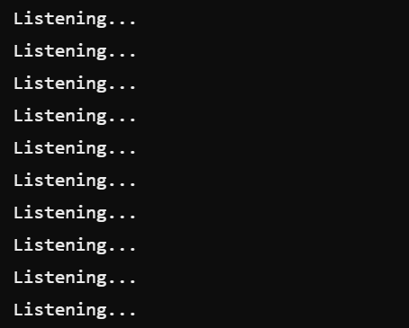

RESULT:

Thus the to do list for GUI CLI,VUI has benn implemented suceesfully .